Celebrating Saint Illtud
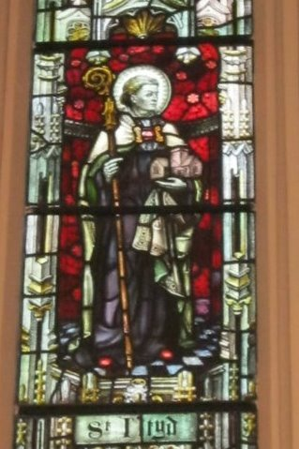
a research study by
Rob Owen
for Creative Rural Communities
June 2018

Contents
- Introduction and background
- Methodology
- Findings
  - Interviews with stakeholders
- Strengths and opportunities
- Weaknesses and challenges
  - Results from questionnaire
- Options and phasing
- Discussion at group meeting
- Conclusions
- Recommendations

Appendix
- Questionnaire sent to Chamber of Trade

1.0 Introduction and background
Creative Rural Communities has recently provided support to a relatively new group in Llantwit Major called ‘Celebrating Illtud’. The group, which consists of approximately 12 members, has an aspiration to increase awareness and appreciation of the importance of Saint Illtud to the development of Celtic Christianity.

Celebrating Illtud has already generated a number of initiatives and ideas and are in the process of fostering relationships with other churches dedicated to the saint, spread across South Wales, Ireland, Cornwall and Brittany.

To support the group and to provide further focus on what could be achieved Creative Rural Communities commissioned Rob Owen to provide three days consultancy. This report summarised the findings of the study and includes the discussion of the Celebrating Illtud group held on the 20th June.

- Methodology

The limited number of days for the study required a focussed approach. To facilitate this the two main methods of acquiring information and insight were based on:

- Face to face interviews with key stakeholders, including:
- Philip Morris, Celebrating Saint Illtud Group
- David Ellis, LLantwit Major Mayor
- Catherine Young, Local History Society
- Canon Edwin Counsell, Saint Illtud Church
- Ruth Quinn, LLantwit Major Town Council Clerk
- Clare Ingram, Chamber of Trade
- Barbara Procter, Andy Smith Foundation
- Nia Hollins, Vale of Glamorgan CC
Attempts were also made to contact a representative from the Events Committee, but this was not possible within the timeframe for the study.
- Issuing a questionnaire to local businesses through the Chamber of Trade.
A copy of the questionnaire is included in Appendix 1.

- Findings
- Interviews
The face to face interviews were very useful and helped to set out a clear picture of the importance of story of Saint Illtud, as well as some of the challenges that the group will have to overcome if they are to meet their objectives.
These are summarised below:
Strengths and Opportunities
- The story of Saint Illtud is undoubtably very important and has the potential to be of considerable appeal to UK as well as international visitors.
- Developing further connections to other Saint Illtud Churches will strengthen the story and illustrate the widespread importance of the saint and his followers.
- The Local History Society is very strong and could play an important role.
- Any future initiatives to promote the story of Illtud will be building on the success of restoration of the Galilee Chapel and establishment of the Blue Plaque Trail.
- Extensive schools work has already done and there is scope to develop this further - thus building on the historical nature of the site as a place of learning.
- The Church are developing new ideas for community engagement, such as an open mike night, which is reaching new members of the community.
- There are other, perhaps more long term opportunities, such as the renovation of the Chantry House and the former kitchen, which could then be used to provide further visitor information and interpretation.

Weaknesses and challenges
- There are a number of distinct but overlapping groups involved in taking part of the overall initiative forward - and although the Celebrating Saint Illtud group has an important coordinating role, there is still a degree of confusion on who is doing what, where and why.
- A key question to emerge was: ‘who would lead any project and hold the money?’ The Celebrating Saint Illtud group is currently not constituted and as such could not apply for funding.
- Thought needs to be given as to how the objectives of the group should be realised: is it another project or a longer term process ? Further discussion is therefore needed to establish clarity on objectives and timescale.
- The web presence is confusing, particularly the relationship between the Friends of Saint Illtud site http://www.illtudsgalileechapel.org.uk/ and the wider site for the church http://www.llanilltud.org.uk
- The local knowledge of Saint Illtud’s story is poor, in fact some residents have never visited the Church in any capacity and may not know of its existence.
- The different spellings of Illtyd and Illtud is confusing.
- Signposting to the Church from main car park is poor.
- Car and coach parking could be a problem, particularly any initiative started to attract more visitors to the town
- Engagement with businesses in the town will take time to develop.

2) Results from questionnaire
Through discussion with the Chair of the Chamber of Trade a short questionnaire was sent out to all members. To provide a clear focus for businesses to react to the main part of the questionnaire asked for reaction to the idea of setting up an annual Saint Illtud festival.

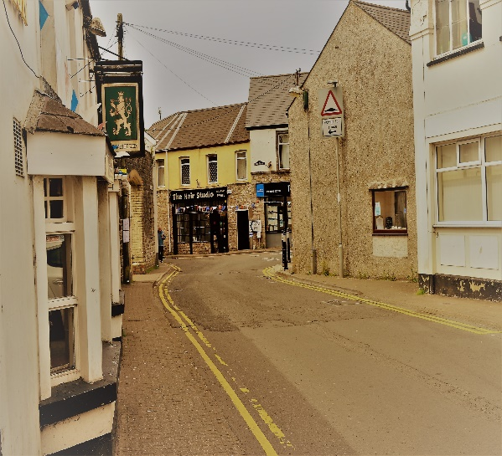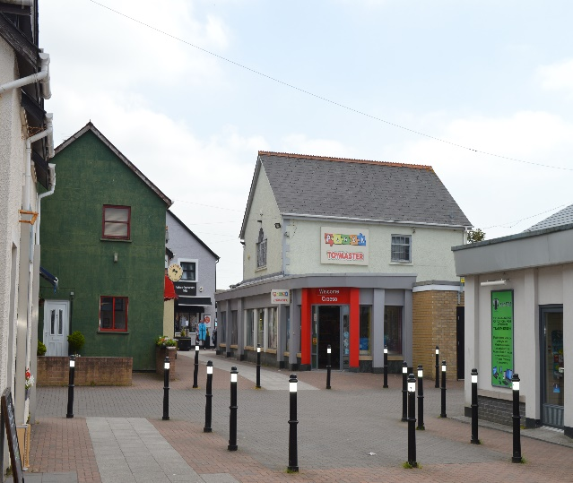

Even after sending a reminder, only four responses were received. Whilst this was disappointing, from information gained through the interviews with key stakeholders the lack of interest was predictable.

Despite the low return, the responses received did indicate strong support for celebrating the story of Saint Illtud.

The following businesses returned the questionnaire:
- Stwff
- Health Conscious
- Treganna
- The Hair Studio

Collating the results therefore does not provide an accurate overview of what traders think about the idea of establishing such an annual event. Nevertheless, there is some merit in looking at the amalgamated results since there are certain businesses who are very keen to support this concept.

Degree to which your business relies on visitors:
Responses ranged from ‘Important’ – ‘Not at all’.

Experience in organising previous tourism events:
Two replied ‘Occasional’ and two ‘Never.’

Would annual festival help business?
Here the answers were very encouraging with two stating a ‘Huge benefit’ and two said it would ‘Help a lot’.

Business were asked if they had any concerns if an annual festival was established
Three replied ‘No’ and one said ‘Unsure’.

Businesses were asked ‘what would be the best time of year to hold a festival?’
Here the answers varied from May to September

Business were offered a range of possible activities which could be part of a festival and asked to tick three.
Most of the responses indicated more than three and this led to following results:

Musical concerts: XXX
Open air theatre: XXX
Medieval fare: XXX
School projects: XXX
Treasure hunt: XXX
Historical Lectures: XXXX
Spirituality and wellbeing: XX

The final question asked whether they would be interested in attending a public meeting to discuss the idea further
The replies were again very positive with two ‘Definitely’, one ‘Possible’ and one ‘No’

The distribution of the questionnaire did produce one unexpected result and that was a phone call from Ian Hunt, the manager of the Filco store.

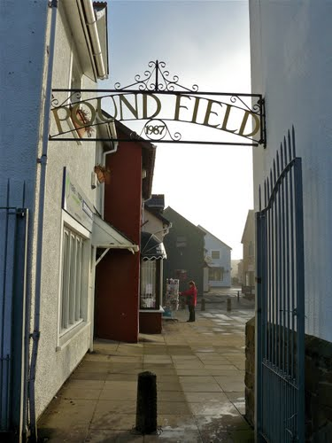
The current names two for the shops in the centre are: “The Precinct” and “Poundfield.” Mr Hunt explained that Filco were considering whether the overall shopping area could be rebranded as the “Saint Illtud Shopping Centre” He indicated that he would welcome views on this and stressed that no decision had been made and that at this stage it was no more than a possibility for the future.

The prospect of rebranding the shopping area in this way offers a number of opportunities for raising awareness of Saint Illtud amongst residents and visitors.

Also, a rebranding exercise might open further possibilities for new signposting and interpretation and this would help address some of the weaknesses and challenges addressed above.

- Options and phasing
Based on the face to face interviews and the returned questionnaire there are a number of possible options that the Celebrating Saint Illtud group could consider and these are listed below:

- Improved web presence, with interactive map showing the location of other churches associated with Saint Illtud and his followers.
- Further research and archaeological survey work to provide more information about the historical importance of Saint Illtud and the role Llantwit Major played in the establishment of Celtic Christianity.
- Holding an annual event or longer festival. There are two possibilities here: holding a festival towards the end of end July to coincide with Saint Samson’s day, or an indoor event on November 6th to coincide with Saint Illtud’s day.
- Discussion with Filco regarding re-branding of Shopping Centre and ascertaining the timing of this along with the possible scope to include further signposting and interpretation.
- Developing a high quality promotional film which could be then shown locally and on a website.
- Securing a marketing and promotion budget to organise a festival and produce high quality leaflets and other publications. There is scope ere to link with local businesses eg producing a special “Cwrw Illtud,” a one-off brew of Illtud beer for an event.
- Longer terms possibility regarding the scope to develop the Chantry Building and the former kitchen for visitor interpretation. This should also consider the area as a whole, including the former dovecot and footpath links to the coast.
- Further discussions with the Town Council and the Vale of Glamorgan CC regarding future car and coach parking. This will only be needed if the group becomes increasingly successful in drawing increasing number of visitors to the town.

- Discussion at group meeting
The above options were discussed at the Celebrating Saint Illtud meeting held on the 20th June and the outcomes are summarised below, along with observations which are shown in red.

 | Options | Discussion
1 | Improved web presence | Discussions are already underway on this and the Saint Illtud Church now have access to the CMS of the main site. The plan is to transfer the content of the restoration of the Galilee chapel into the main Saint Illtud site. This will consolidate the web presence.  A question arises though as to whether this church site can be further developed to incorporate the wider story of Illtud and other churches dedicated to him. This poses:  - technical questions in that is the web platform suitable to house an interactive map?  - editorial issues in that the site might then be trying to provide information for different audiences i.e. church users and visitors to the town.
2 | Further research and archaeological survey work | The Smith Foundation is already in the process of funding some of this work through the archaeology department of Cardiff University. The timing for this work is not yet clear but it does pose potential to discover new insights into the area’s history. The discovery of new facts could have very significant positive impact in meeting the group’s objectives of raising awareness of the Saint Illtud story.  It will be important that this aspect is closely linked to other initiatives and does not happen in isolation. As the survey work gets under way there is considerable scope to link to the website and generate further publicity and awareness.
3 | Annual Festival | There will be an event around November 6th in the West Church to Commemorate WW1 and this is being taken forward by the Town Council. There is scope to incorporate a parallel exhibition and talks relating to Saint Illtud as part of this, and this could make a significant contribution to increasing awareness of Saint Illtud amongst local residents.  Staging this event with two themes offers a number of possible benefits, but it will need to be well organised and publicised in a clear way. There is a danger that the messages are mixed and therefore confusing. That said, it could provide a very useful foundation stone for a more ambitious event or festival on Saint Illtud in 2019. Early discussions with local businesses will be important in getting wider buy-in to the event.
4 | Discussions with Filco re rebranding he shopping centre | There was strong support for this.  Detailed discussions with Filco are now needed to take this forward and get a clearer picture on possible timing and the scope to incorporate further visitor information and signposting.
5 | Promotional film | One film about the history of the town is already in production, and this is being funded through the Smith Foundation.  If the film is finished in time it could be premiered at the event planned for November the 6th. The film could also be shown on the planned improved website. It could also spark interest in producing further films that can tell the wider story of Illtud’s influence in establishing Celtic Christianity.
6 | Marketing and promotions budget | There are several funding streams available to boost the group’s efforts in terms of marketing and promotion. These include the Tourist Product Innovation Fund (TPIF) managed by Visit Wales, as well as funding for organising festivals and events which are available through the Arts Council for Wales.  The key here will be establishing coherent plans and establishing a constituted group which can hold and manage budgets. If the ambitions of the group are to be fully realised, then this issue will have to be addressed at some stage.
7 | Chantry and Kitchen buildings | These offer possibilities, but the priorities of the Church at the moment need to focus on the maintenance of the main tower.  The upgrade of the former kitchen to a small interpretative building suitable for showing films is practical and would not require many resources. This though is a second phase and would need to follow some of the above options. The repair, renovation of the Chantry building is a far longer prospect and would require more detailed plans and discussions with Cadw and the Vale of Glamorgan CC. It will be important that this is considered in an integrated and comprehensive way and to take in the adjoining dovecot and footpath links to the coast. There is considerable scope for interpretation here.
8 | Car and coach parking | One of the restrictions in attracting more visitors to the town is the potential for congestion and overcrowding, particularly in terms of limited car and coach parking.  The possible rebranding of the Precinct and Poundland offers possibilities to look at traffic management in the town. There may be further possibilities to improve car parking and to develop a weekend coach through liaising with Saint Illtud School.

- Conclusions
There is no doubt that the significance of Saint Illtud in the development of early Christianity into Britain is one of our ‘great untold stories’ - and it is somewhat astonishing that its importance is not already widely acknowledged and celebrated throughout the UK and internationally.
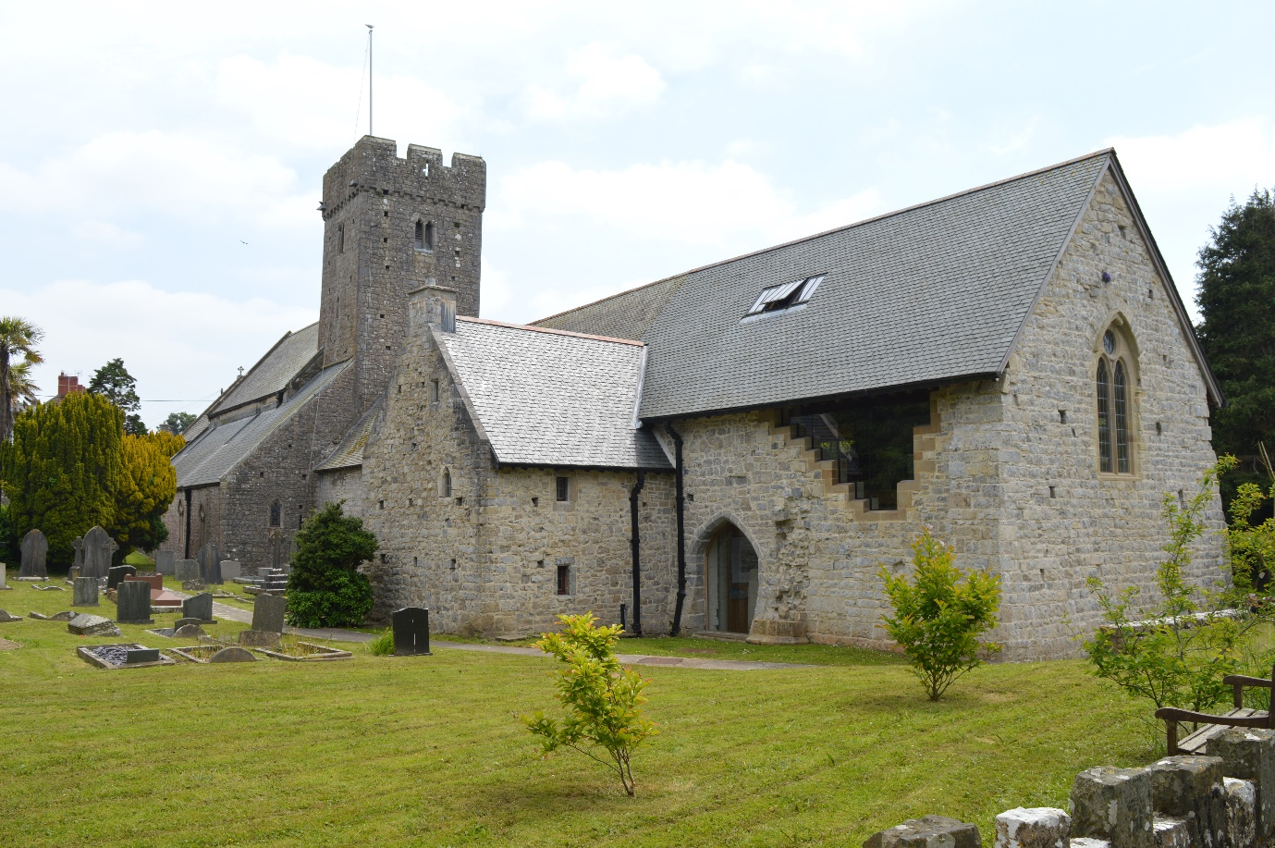
It is also interesting to note that international visitors are becoming increasingly aware of Saint Illtud - and no doubt the renovation of the Galilee Chapel, along with the establishment of ‘welcomers’ to the church, has played a significant part in this.
The Celebrating Saint Illtud group has already been successful in stimulating interest and importantly coordinating and improving communication between other groups. But for the objectives of the group to be fully realised it will need to adapt its governance structure.
The key question here is whether the group is largely restricted to associations with Saint Illtud’s Church and its work, or whether its ambitions and activities reflect the wider community? If the prospect of telling the story of Saint Illtud is to be realised - even in part - then clearly a wider representation from the community will be required, and particularly from the business sector.
The group also need to consider how they may become a body that can accept grant aid and what form of further support from Creative Rural that they would like to draw upon.
Out of the 8 options put forward, some are already under way, and this is encouraging. However, there is a danger that they will be developed in an isolated and uncoordinated way and, as such, significant opportunities may be missed. For instance: if an event celebrating Saint Illtud is developed for November 6th, could this coincide with the premiering of the planned promotional film, and will this tie into the possible rebranding of the shopping centre?
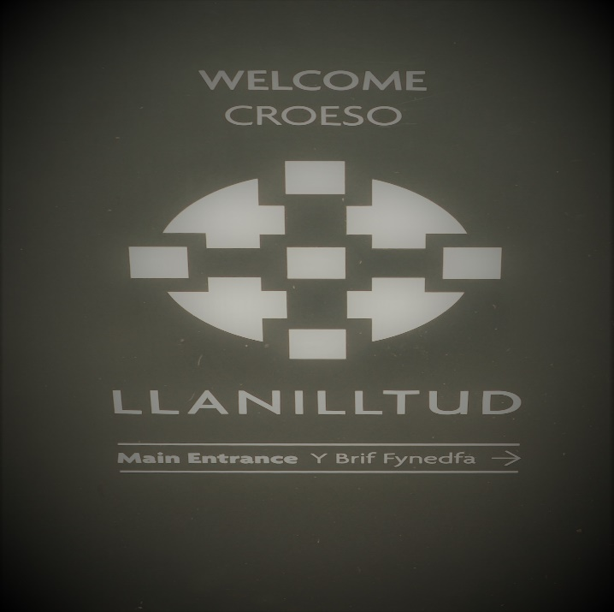
There is also the issue of branding and public awareness. The immediate step should be to develop a clear brand to depict the group’s work and its ambition. This will be important in linking the current initiatives together and showing that they are all part of a bigger picture.
Then there is the wider issue of the different spellings of Illtud and indeed the English name of Llantwit Major. As the group’s work develops over the years there maybe to scope to influence the local authority, developers and others to rename and correct the spelling of streets etc.
Eventually, the town may become known primarily at LLanilltud Fawr, with the English name of lesser significance. This will take time, but if achieved it would be a mark of success for the group and reinstate Illtud’s importance on the map!
The overall potential of raising awareness, interest and involvement in the story of Saint Illtud and his influence on early Christianity is enormous and if handled in the right way this could bring significant economic benefits to Llantwit Major. However, not all forms of tourism are entirely beneficial – there are inevitably negative impacts and understating what these might be and how to handle them will be important.

- Recommendations
The following four recommendations are put forward to the Celebrating Saint Illtud group and to Creative Rural Communities:
- Establish quick wins
Focussing on a joint event for November 6th provides a clear focus for testing the appetite for bringing the story of Saint Illtud to a wider audience. It will be vital that this takes place in a coordinated way, ensuring that any potential opportunities arising from either the production of the promotional film, or the potential rebranding by Filco are maximised. If this is successful, then it provides a valuable springboard from which the group can set more ambitious goals.
- Consider the governance of the group
The responses from Health Conscious and Treganna were very supportive and consideration should be given as whether they should be invited to be part of the Celebrating Saint Illtud group. This would bring in new ideas, energy and technical skills.
If the wider ideas are to be taken forward, then at some stage the group will need to consider its governance structure. Operating largely as a liaison and coordinating group has been effective to date, but to take forward more ambitious plans will require a more formal arrangements. It would not be difficult for the group to be constituted, but there would need to be some clear boundaries established in terms of its relationships and dependencies on other groups notably: the Friends of Saint Illtud, the History Society, Saint Illtud Church, the Town Council, the Events Committee and the emerging archaeological survey work to be carried out in the area.
- Develop a clear brand and identity
Because of the numerous existing initiatives underway, as well as the potential to develop further ideas, it will be vital that there is a clear and well-defined brand identity to link activities together. This will help consolidate the messages that the group wish to portray.
- Draw up a costed and clear plan with measurable outputs.
From the above, the group would be in a good position to draw up a clear and costed plan with measurable outputs set out against an agreed timescale. To develop such a plan will be important in providing focus and direction.
Undertaking a ‘Theory of Change’ exercise would be a useful way to show clarity between the group’s: vision, desired outcomes, outputs and its activities. Support from Creative Rural Communities would be useful to assist the group undertake such an exercise.
Appendix 1

Celebrating Saint Illtud
Introduction
Llantwit Major takes its name from the religious and spiritual teacher, Saint Illtud, but how many residents, visitors and businesses owners have heard of him and his work?
In the early 6th century Illtud established what became one of the most esteemed Christian colleges of the time, attracting thousands of students, including princes and future saints to the area. The college is widely recognised as the first university in Britain.
A new local group called “Celebrating Saint Illtud” has been established and they have started to contact the numerous churches dedicated to Illtud and his followers. These are spread through Wales, Cornwall, Ireland and Brittany. There is potential to link these sites and promote faith-based and heritage tourism - and this would draw on the Vale’s rich heritage assets and the unique history associated with Illtud and Llantwit Major.
The group would therefore like to consult residents and businesses on whether raising awareness of Saint Illtud and his work would benefit those who live, work or visit Llantwit Major. One possible idea would be to hold an annual event which would draw visitors from a wide area.
I have been commissioned by the Vale of Glamorgan CC to support the Celebrating Saint Illtud group and seek the views of residents, community groups and businesses in Llantwit Major on this matter.
I would therefore be very grateful if you could spare 5 minutes to complete the short questionnaire below and return to:
rob@bro.cymru by the 31st May
Many thanks,
Rob Owen
07734568509

Celebrating Saint Illtud
About your business or organisation
Name of your business
Contact details
Your name
Phone number
E-mail
Website

Reliance on visitors to Llantwit Major
To what degree does your business or organisation rely on day and staying visitors to Llantwit Major?
Please tick one box
Very important
Important
Some benefit
Little benefit
Not at all at all

Previous tourism events and festivals
Have you been previously involved in organising or delivering any previous events or festivals aimed at attracting visitors to Llantwit Major?
Please tick one box
Yes many
Occasionally
Never

Further information if applicable

Benefits of celebrating the life and work of Saint Illtud
Do you think that Llantwit Major would benefit from organising an annual Saint Illtud festival, or a series of events, to attract visitors to the town?
Please tick one box
Huge benefit
Help a lot
Some benefit
Little benefit
No benefit

Would this benefit your own business or organisation?
Please tick one box
Huge benefit
Help a lot
Some benefit
Little benefit
No benefit

Please elaborate if needed
Would you have any concerns about such an annual festival or events?
Please tick one box
Yes
No
Not sure
Please elaborate if needed
If such an annual Saint Illtud festival was organised what would be the best time of year to do this?
Please tick month
J | F | M | A | M | J | J | A | S | O | N | D

What activities do you think should be organised as part of such an annual festival?
Please tick up to three ideas
Possible activities
Musical concerts indoors
Open air theatre
Medieval fair
School projects and events
Treasure hunts
Historical lectures and talks
Spiritual and wellbeing sessions
Other (please specify)

Finally, we are thinking about organising an evening meeting to discuss the ideas further. This would be towards the end of July. Would you be interested in attending such a meeting?
Please tick one box
Yes definitely
Possibly
Not interested

Thank you again for taking the trouble to complete this. As indicated, please return to:
Rob@bro.cymru by the 31st May

