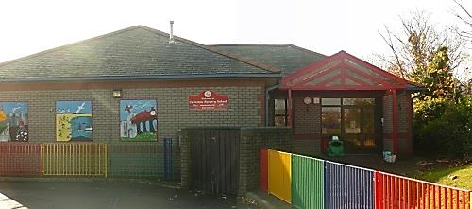
Supplementary Information

On the proposal to amalgamate Cadoxton Nursery and Cadoxton Primary schools by:

- Extending the age range of Cadoxton Primary School from a 4 to 11 to a 3 to 11 years primary school and;
- Amalgamating Cadoxton Nursery and Primary schools by discontinuing Cadoxton Nursery school.

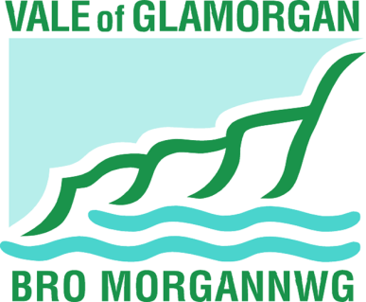

This document can be made available in Braille.

Information can also be made available in other community languages if needed.

Please contact us on 01446 709727 to arrange this.

FOREWORD

This document provides supplementary information about the proposal to amalgamate Cadoxton Nursery and Cadoxton Primary schools by:

- extending the age range of Cadoxton Primary School from a 4 to 11 to a 3 to 11 years; and;
- discontinuing Cadoxton Nursery School.

Three alternative options were considered as part of the development of the proposal. They are described below. Information on the proposal, including its advantages and disadvantages can be found on pages 18 and 19 of the consultation document

The original consultation document, along with details on how to respond, can be viewed online at www.valeofglamorgan.gov.uk/cadoxtonschools.

Please note the closing date for comments is 15 February 2015.

Alternatives considered

A summary of the alternative options and the reasons these were not recommended are provided below:

Do nothing and maintain schools in their present form

Maintaining the status-quo does not provide the benefits associated with school amalgamation as outlined in the proposal. One of the main benefits of moving to an ‘all through’ primary school is to minimise the number of transitions between schools that children experience. The current arrangements are expensive and limit the opportunities for teachers and support staff to work with children of different ages.

An amalgamation would build on the strengths present in the existing separate schools under a single leadership team, providing additional efficiency and opportunity which would not be available under separate management structures. Staff would also benefit from continuing professional development opportunities by enabling them to gain experience across the foundation phase and key stage 2. These advantages would not be present by maintaining the status-quo.

This option would avoid any change or potential disruption.

Federate the two schools

Federating the two schools would mean that the schools would remain two separate legal entities with separate budgets, staffing structures and organisational structures, but with a single governing body overseeing the two schools. Each school would also be subject to separate inspections.

This approach does not have the benefits of a single organisational structure and would not result in the operational efficiencies outlined in the proposal to amalgamate. Federation would also continue an undesired additional transition for pupils.

Amalgamation by closing both schools and open a new school

This proposal would involve the closure of both schools and the establishment of a new primary school. A new governing body for the new school would need to be established, which would decide a new staffing structure and appoint the new headteacher.

A new set of policies and a new governing body would need to be established and implemented, and new curriculum plans and monitoring arrangements would have to be put into place.

This option would be likely to cause the most disruption to both schools and would mean that the amalgamation process would take longer to complete.

It would, however, remove the unnecessary transition and does have the benefits of a single organisation structure and the operational efficiencies outlined in the proposal.

