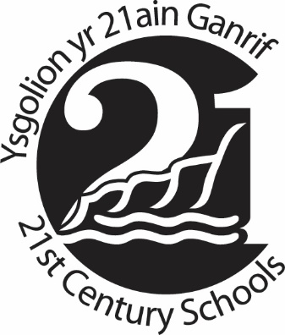
21st Century Schools Programme Community Benefits - Application Form
This application form is to submit your project’s interest to take part in the community benefits scheme as part of the 21st Century Schools programme within the Vale of Glamorgan.
Please complete this application form and submit to 21stcenturyschools@valeofglamorgan.gov.uk
Please note this form reflects your preferred contribution and acceptance of your project onto the community benefits scheme does not necessarily mean all your requirements will be met.
(Please scroll down to complete the application form in Welsh.)
Project contact details
Name of project:
Name of main contact:
Email:
Phone:

Briefly summarise what your project is about… (150 words maximum)

Where does your project operate within the Vale of Glamorgan? (specific area or whole of the Vale of Glamorgan)

When would you need support? (e.g. specific month / in the summer)

For how long would you need support? (e.g. one off / two weeks)

What support would you like from the contractors? (e.g. time volunteered on a project / access to work experience opportunities for service users) (300 words maximum)

What might the impacts of support be on your project? (e.g. meeting targets for service users supported / improving spaces your project can offer the community) (300 words maximum)

What might the impacts of support be on the social, environmental, and economic sustainability of the wider Vale of Glamorgan community? (e.g. better community facilities / increased employment) (300 words maximum)
Please direct any queries to 21stcenturyschools@valeofglamorgan.gov.uk or phone 01446709828

Buddion Cymunedol Rhaglen Ysgolion yr 21ain Ganrif – Ffurflen Gais
Diben y ffurflen gais hon yw cyflwyno diddordeb eich project i gymryd rhan yn y cynllun buddion cymunedol fel rhan o raglen Ysgolion yr 21ain Ganrif ym Mro Morgannwg.
Cwblhewch y ffurflen gais a’i chyflwyno i 21stcenturyschools@valeofglamorgan.gov.uk
Cofiwch fod y ffurflen hon yn adlewyrchu eich cyfraniad o ddewis ac os caiff eich project ei dderbyn ar y cynllun buddion cymunedol nid yw hynny o angenrheidrwydd yn golygu y bydd eich holl ofynion yn cael eu bodloni.
Manylion cyswllt y project
Enw’r project:
Enw’r prif gyswllt:
E-bost:
Ffôn:

Nodwch yn gryno beth mae eich project yn ei wneud... (Dim mwy na 150 gair)

Ymhle mae eich project yn gweithredu ym Mro Morgannwg? (ardal benodol neu ar hyd a lled Bro Morgannwg)

Pryd byddech chi angen cymorth? (e.e. mis penodol / yn yr haf)

Am ba hyd byddech chi angen cymorth? (e.e. un tro / pythefnos)

Pa gymorth yr hoffech chi gan y contractwyr? (e.e. amser gwirfoddolwyr ar broject / mynediad i gyfleoedd brofiad gwaith ar gyfer defnyddwyr gwasanaeth) (dim mwy na 150 gair)

Sut gall y cymorth effeithio ar eich project? (e.e. cyrraedd targedau ar gyfer defnyddwyr gwasanaeth, cefnogi / gwella lleoedd y gall eich project eu cynnig i'r gymuned) (dim mwy na 300 gair)

Sut gall y cymorth effeithio ar gynaliadwyedd cymdeithasol, amgylcheddol ac economaidd y gymuned Bro Morgannwg ehangach? (e.e. cyfleusterau cymunedol gwell / mwy o swyddi)
Cyfeiriwch unrhyw ymholiadau i 21stcenturyschools@valeofglamorgan.gov.uk neu ffoniwch 01446709828

