Substance description: Hycolin Professional Antiviral Multi-purpose Cleaner | Assessor: Elaine Harris

Assessment completion date: 15.03.2021 | Review date:

Activity/Description | Hazard | Risk | Preventative  Measures | First aid measures | Storage/handling | Training
Detergent, disinfecting cleaning  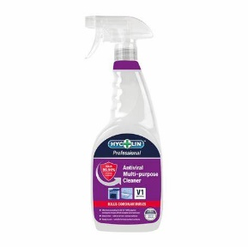 | Classification according to Regulation (EC) No. 1272/2008  See risks and follow first aid measures  as required  Keep out of the reach of children  Dispose of contents/container in accordance with local waste requirements  Breathing apparatus may be required for firefighting. Prevent run off to watercourses | Skin irritation, dryness, redness with prolonged use  Can cause temporary eye irritation with contact or prolonged use  Can cause Stomach  pain. Nausea, vomiting. Diarrhoea with over exposure  If medical advice needed, have product or label at hand.  Read label before use.  Wash hands thoroughly after use. | No PPE generally required, however: anybody with a skin condition or with prolonged use, should wear disposable gloves  Use in adequate ventilation  Do not use in addition to other products | Inhalation – Fresh air, rinse nose/ mouth with water  Skin contact – Remove contaminated clothing rinse with water, get medical attention if any discomfort/irritation continues.  Eye irritation – Promptly rinse eyes with plenty of water cautiously, with eyelids wide open, remove contact lenses, get medical attention if any discomfort continues.  Ingestion –  Do not induce vomiting. Rinse mouth with water, obtain medical advice | Handling  If have sensitive skin of for prolonged use wear gloves.  Use of hand creams post use  Wash hands thoroughly after use.  Storage: Store in tightly closed original container in a dry, cool and well-ventilated place.  Keep out of reach from children | Follow content of this assessment at all times.

