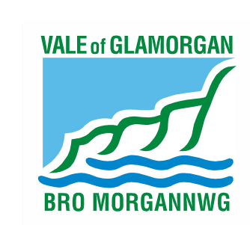

Candidate and Agent Information

and

Nomination Pack

Local Government Elections

Thursday 5 May 2022

Submitting Nomination Papers Electronically

Nomination papers submitted electronically must be delivered in accordance with arrangements set out below.

The email address to submit nominations is nominations@valeofglamorgan.gov.uk. Please use this email address for any queries and/or informal checks. The subject heading should include the name of the candidate and the affiliated party (if applicable).

We would strongly advise you to check that your nomination papers have been received by telephoning 01446 709304.

It is the responsibility of candidates to ensure that the Returning Officer receives the nomination papers in the correct way by the required deadline.

An electronic read receipt from the Returning Officer is not confirmation that the nomination
is valid. The Returning Officer will send a notice to inform candidates of their decision as to whether or not their nomination is valid.

Delivering Nomination Papers Face to Face

If you would prefer to bring your Nomination papers into the Civic Offices (Holton Road, Barry, CF63 4RU) we would appreciate you telephoning 01446 709304 in order to make an appointment.

Appointments are available from Tuesday 22 March 10am until close of nominations on Tuesday 5 April at 4pm.

Electoral Registration Contact Information

Electoral Registration Office
Vale of Glamorgan Council
Civic Offices
Holton Road
Barry
Vale of Glamorgan
CF63 4RU

Email: electoralregistration@valeofglamorgan.gov.uk

Tel – 01446 709748

Electoral Registration Manager – Rachel Starr-Wood
rmstarr-wood@valeofglamorgan.gov.uk
01446 709304
Office Mobile:

Electoral Registration Deputy – Hayley Hanman
HHanman@valeroglamorgan.gov.uk
01446 709345

Returning Officer (RO) & Electoral Registration Officer – Rob Thomas
Electoral Registration Office, Vale of Glamorgan Council, Civic Offices,
Holton Road, Barry, Vale of Glamorgan, CF63 4RU

Deputy Returning Officer (DRO) & Deputy Electoral Registration Officer – Victoria Davidson
Electoral Registration Office, Vale of Glamorgan Council, Civic Offices,
Holton Road, Barry, Vale of Glamorgan, CF63 4RU

ELECTORAL COMMISSION

Further candidate and agent’s guidance can be found on the Electoral Commissions website

Spending and donations

If you have any queries relating to spending, donations and election payments please contact the Electoral Commission office directly on 0333 103 1929 or Email: infowales@electoralcommission.org.uk

