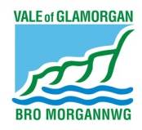
TRAFFIC LIGHT STRATEGY
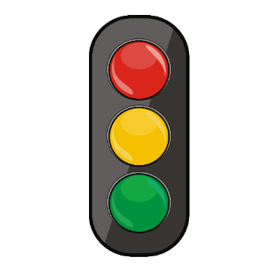
What is it used for?
The traffic light cards is a visual strategy used to communicate to children when an activity is about to start, when it nearly finished and when that activity has finished. The strategy can help children to manage transition between different activities by visually telling them that something is about to start, is nearly finishing or has finished.

How to make a set of traffic light cards
Each traffic light symbol should be about the size of a CD and be on red, yellow and green card. Each colour symbol should have the appropriate widget symbol to remind staff of the purpose of each coloured card and the correct language to use.
- Red symbol should have the ‘starting’ widget.
- Yellow symbol should have the ‘nearly finished’ widget.
- Green symbol should have the ‘finished’ widget.

How to use the traffic light symbols
The green symbol should be used to indicate and activity is about to start. Try to establish eye contact with the child if possible and if necessary, prompt the child to touch the symbol to reinforce.
Hold up the card and say, “ is starting.”

The yellow symbol is the most important of the three as it gives a warning of when an activity is nearly finished, or when access is about to be withdrawn. As above ensure eye contact with the symbol is gained, if necessary prompt the child to touch the yellow symbol to reinforce.
Hold up the card and say, “ nearly finished.”

The red symbol indicates that an activity has finished.
Hold up the card and say “ finished.”
Once you have shown the red symbol it is not negotiable. You must follow this through.
Top Tips
- There must be consistency if the system is to work.
- It should be used by all staff involved with the child.
- Remember to keep your language simple and use the same words when using traffic lights, ‘’ starting’; ‘ nearly finished’; ‘ finished’
- The yellow symbol can also be used to mean ‘it is nearly time’ and ‘wait’ as well as ‘nearly finished’
- Try to incorporate the use traffic lights throughout the day, e.g. snack time, carpet session, play activity, outdoor play, snack time, nappy changing etc
- For something that is not available, use the red symbol and say e.g. “outdoor finished.”

