BITING BEHAVIOUR
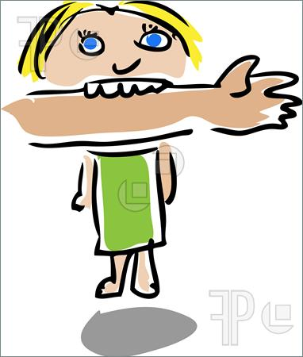 Introduction
Young children explore the world with their mouth and biting is a natural extension of that process. The urge to bite arises from this natural curiosity and it can be linked to feelings of stress, frustration and excitement.

Reasons for Biting and Possible Solutions
In order to manage biting effectively in settings, staff must discover the reason as to why a child may bite and the function that biting serves.

Teething: Provide a range of chewable toys / teething rings for the child to bite. Offer crunchy snacks as research has shown that crunchy snacks can actually reduce biting incidents.

Natural curiosity: Offer variety of activities that involve the child’s senses. Anything physical such as sand, water, playdough

Excitement: If the child is easily overwhelmed you can make reasonable adjustments. Create a quiet area with cushions, books and other quiet sensory toys as a safe place to take a break.

Frustration: Where possible avoid situations that the child might find frustrating and intervene if you see them becoming frustrated. If the child is getting overwhelmed, limiting their choices to no more than two things may help.

Attention Seeking: It is important to not react too loudly or strongly in biting situations as the child will have got attention they are seeking. Instead provide praise and positive attention when the child isn’t biting and is playing nicely.

Positively managing biting
- Encourage the use of words. Put into words what you guess the child might be thinking: ‘Do you want a turn on the tricycle? You can ask Henry, “Can I have a turn now?”’
- Observe the child within the setting and look at how to manage situations where the child might bite. Step in to make sure the situation is kept under control.
- Make sure the child who bites has enough personal space and help them to find a peaceful area to do something quiet if you spot any behaviour which might lead to biting.
When the child does bite
No matter how proactive you are there is still a good chance that the child will bite when in a group environment. When this does happen follow the course of action outlined below.
- Act calmly, maintain a quiet and controlled voice, remove the biting child from the situation and say calmly but in a firm voice say ‘No bite’ and that ‘Biting hurts’.
- Take care of the child who has been bitten first, calm the child and check the bite.
- Help the child who bites understand about cause-and-effect, ‘When you bite, it hurts your friends. Biting is never okay’. Make sure the child understands that biting is not a game.

Top Tips
- Wear long sleeves. When being bitten- press into the bite. Do not be tempted to pull away as this may cause more harm.
- Read stories to reinforce: Teeth Are Not for Biting by Elizabeth Verdick, No Biting by Karen Katz, No Biting Louise by Margie Palatini

