BEHAVIOUR MANAGEMENT
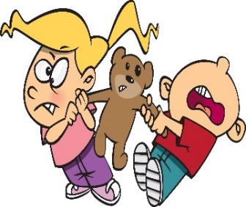
Introduction
Many children in early years settings can display challenging behaviour and it can often feel like you have tried every technique and followed all the advice given. However there is always something which can be done to improve the situation it is just trial and error and patience to find the correct techniques to support the individual.

Seven steps to reducing challenging and difficult behaviour

Step 1 - Identify the challenging behaviour
As always, the place to start is with observations. Try to be as specific as possible about which behaviour you want to change. When observing make a note of the time the behaviour was displayed; the children that were around; the environment the child was in; what happened before, during and after the incident and the trigger if there was one.

Step 2 - Identify what you want the child to do instead
If you think of the opposite behaviour to the problem, this will be what you want the child to do. This will also indicate whether your behaviour management techniques have been successful.

Step 3 - Think of a way to motivate the child to change
Although you will praise the good and ignore the negative, this cannot be applied to all situations so it may be necessary to think of other behaviour management techniques such as alternative rewards that you can use i.e. access to a special toy, being ‘a helper’ getting a sticker. Remember it will need to be immediate so the child associates it with the desired behaviour.

Step 4 - 'Fine tuning' your techniques
Think of any other changes that can help the child to learn the new behaviour. Other strategies could include use of visual sand timers, removing anything that can cause harm, creating routines, developing relationships with key worker and positive behaviour techniques. Whatever strategies you try remember to stay calm, be consistent with your approach and stick to it and tune in to what the child is trying to tell you through their behaviour.

Step 5 - Decide what you are going to do when the problem occurs
What is going to be your response when the problem occurs? Are you going to use distraction, active ignoring, verbal reminder i.e. ‘We don’t do hitting in setting’.

Step 6 – Record Keeping
Use a STAR Observation chart so that you can keep track of your progress. The record needs to record:
Setting: Where did it occur? i.e. outside area;.. snack time…
Trigger: What was the trigger that resulted in the behaviour? i.e. time to tidy up; toy being taken…
Actions: What was the child’s action to the trigger? i.e. hitting out at others; biting own hand…
Results: What was the result of the action? i.e. removal from situation; calm down time…

Step 7 - Review after a few weeks
Are you getting an improvement in the behaviour? Consider the following questions:
- Is the behaviour that I am expecting too difficult for the child?
- Can I make it a bit easier for the child to achieve success?
- Do I need to change the way in which I am trying to motivate the child?
- What else can I do to encourage the desired behaviour to occur?

