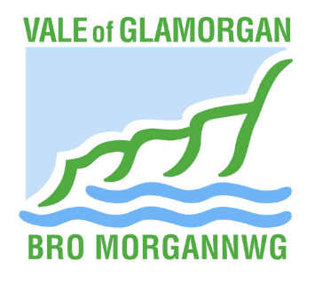
The Vale of Glamorgan Council
Dock Office, Barry Docks, Barry. CF63 4RT
Tel: 01446 704681Ff01446 700111
Email: planning@valeofglamorgan.gov.uk
www.valeofglamorgan.gov.uk
Ebpanning@valeofglamorgan.gov.uk
Statutory pre-application advice enquiry form
Please complete this form with as much information as possible. Any incorrect completion will delay the processing of your application.
If you require any further information regarding the statutory pre-application service or how to complete this form, please contact the authority on: 01446 704681 or email to planning@valeofglamorgan.gov.uk
Applicant Name, Address and Contact |  | Agent Name, Address and Contact
Name: |  | Name:
Address: |  | Address:
Postcode: |  | Postcode:
Tel. No.: |  | Tel. No.:
Mobile No.: |  | Mobile No.:
Email: |  | Email:

Description of the Proposal

Total number of new units:

(if applicable)

Increase in floor space (m²)

Site Address (if different to applicant’s address) |  | Location Plan  Please check the box below to confirm you have submitted a plan (which identifies the land to which this application relates, preferably in red), drawn to an identified scale and showing the direction North. The plan should preferably be to a scale 1:1250  I have attached a location plan that meets the requirements outlined above:
Address:
Postcode:

Additional Information
To help ensure your local Planning authority can provide the best possible response to your pre-application enquiry, you are encouraged to submit as much additional information as possible to accompany this form. Please provide any additional information you are submitting below (continue on a separate sheet if necessary):

Statutory Pre-App Fee:
*where
- Dev exceeds 24 houses
- Site area exceed 0.99 ha (where no. of dwellings, gross floorspace is not known or where there is a material change in use in the land)
- Non-residential / change of use floorspace exceeds 1,999 sq.m.
Householder £25
Minor Dev. £250
Major Dev. £600
Minerals and Waste £600
Large Major Dev.* £1000
Non-Statutory Pre-App meeting fee is £160 (incl. VAT) (in addition to the above fee)
Please tick here if you are requesting a non-statutory meeting
I confirm that the correct fee of £ has been included with this enquiry form:
If you are unsure of the correct fee you are required to submit, the full fee schedule can be found:
https://www.valeofglamorgan.gov.uk/en/living/planning_and_building_control/Planning/Planning-Applications/Make-a-Planning-Application.aspx

Signed (applicant):  or  Signed (agent): | Date (DD/MM/YYY):

This form is available in Welsh / Mae’r ffurflen hon ar gael yn
Gymraeg

